THE FISH BOMBER PROBLEM
STEP 1
DEFINE THE PROBLEM
This application will have a user drop a torpedo in order to have it collide with one of the two swimming fish in the water. The user is to control the submarine that launches the torpedo by using the left and right keys. To launch the torpedo the user is to press the spacebar. When launching a torpedo the user loses 1 point. When the torpedo hits a fish, the fish image turns into the skeleton of a fish and drops to the bottom. At this point the user is given 2 points for a total earning of 1 point. When the user reaches 25 points the game will end and it will show how long it took the user to get to 25 points while playing the game.
STEP 2
DESIGN A SOLUTION
a) User Interface Design
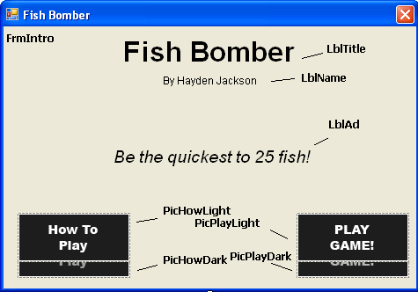
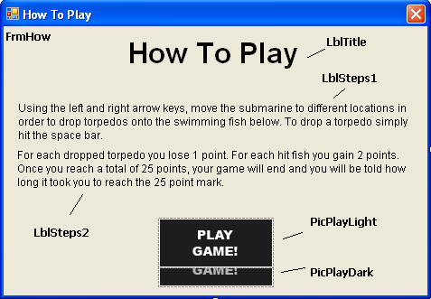
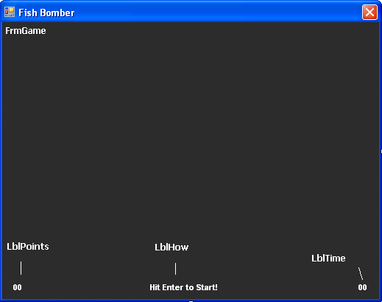
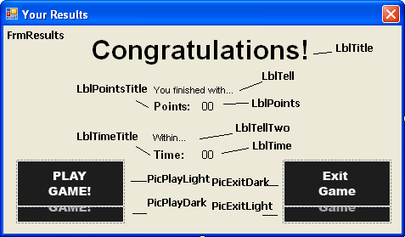
b) Form Settings
FRMINTRO.CS
Control Object type Property New Setting Purpose
Form Name FrmIntro
MaximizeBox False Disables maximization
MinimizeBox False Disables minimization
Size 477, 332 Gives form size
StartPosition CenterScreen Starts form in center of screen
Text FishBomber Gives form a title
LblTitle Name LblTitle
Font Arial, 24pt, style=Bold Changes label font
Text Fish Bomber Label’s text
TextAlign TopCenter Aligns text to top center of label
LblName Name LblName
Font Arial, 9pt Changes label font
Text By Hayden Jackson Label’s text
TextAlign TopCenter Aligns text to top center of label
LblAd Name LblAd
Font Arial, 14.25pt, style=Italic Changes label font
Text Be the first… Label’s text
TextAlign TopCenter Aligns text to top center of label
AutoSize True Auto sets width to text size
PicHowDark Name PicHowDark
SizeMode AutoSize Auto sets box to image size
PicHowLight Name PicHowDark
SizeMode AutoSize Auto sets box to image size
Visible false Doesn’t show image
PicPlayDark Name PicPlayDark
SizeMode AutoSize Auto sets box to image size
PicPlayLight Name PicPlayDark
SizeMode AutoSize Auto sets box to image size
Visible false Doesn’t show image
FRMHOW
Form Name FrmHow
MaximizeBox False Disables maximization
MinimizeBox False Disables minimization
Size 477, 332 Gives form size
Control Object type Property New Setting Purpose
StartPosition CenterScreen Starts form in center of screen
Text How to Play Gives form a title
LblTitle Name LblTitle
Font Arial, 24pt, style=Bold Changes label font
Text How To Play Label’s text
Lbl Steps1 Name LblSteps1
Font Arial, 9pt Changes label font
Text Use the left and… Label’s text
Lbl Steps2 Name LblSteps2
Font Arial, 9pt Changes label font
Text For each dropped… Label’s text
PicPlayDark Name PicPlayDark
SizeMode AutoSize Auto sets box to image size
PicPlayLight Name PicPlayDark
SizeMode AutoSize Auto sets box to image size
Visible false Doesn’t show image
FRMGAME
Form Name FrmGame MaximizeBox False Disables maximization
MinimizeBox False Disables minimization
Size 520, 410 Gives form size
StartPosition CenterScreen Starts form in center of screen
Text Fish Bomber Gives form a title
LblPoints Name LblPoints
Font Arial, 8.25pt, style=Bold Changes label font
ForeColor White Changes font color
Text 00 Label’s text
LblHow Name LblHow
Font Arial, 8.25pt, style=Bold Changes label font
ForeColor White Changes font color
Text Hit Enter to Start! Label’s text
LblTime Name LblTime
Font Arial, 8.25pt, style=Bold Changes label font
ForeColor White Changes font color
Text 00 Label’s text
FRMRESULTS
Form Name FrmResults MaximizeBox False Disables maximization
MinimizeBox False Disables minimization
Size 477, 279 Gives form size
StartPosition CenterScreen Starts form in center of screen
Text Your Results Gives form a title
LblTitle Name LblTitle
Font Arial, 24pt, style=Bold Changes label font
Text Your Results! Label’s text
LblTell Name LblTell
Font Arial, 8.25pt Changes label font
ForeColor Black Changes font color
Text Label’s text
LblTellTwo Name LblTellTwo
Control Object type Property New Setting Purpose
Font Arial, 8.25pt Changes label font
ForeColor Black Changes font color
Text Label’s text
LblTimeTitle Name LblTimeTitle
Font Arial, 9.75pt, style=Bold Changes label font
AutoSize True Changes font color
Text Time: Label’s text
LblPointsTitle Name LblPointsTitle
Font Arial, 9.75pt, style=Bold Changes label font
AutoSize True Changes font color
Text Points: Label’s text
LblPoints Name LblPoints
Font Arial, 9.75pt Changes label font
AutoSize True Changes font color
Text 00 Label’s text
LblTime Name LblTime
Font Arial, 9.75pt Changes label font
AutoSize True Changes font color
Text 00 Label’s text
PicPlayDark Name PicPlayDark
SizeMode AutoSize Auto sets box to image size
PicPlayLight Name PicPlayDark
SizeMode AutoSize Auto sets box to image size
Visible false Doesn’t show image
PicExitDark Name PicExitDark
SizeMode AutoSize Auto sets box to image size
PicExitLight Name PicExitDark
SizeMode AutoSize Auto sets box to image size
Visible false Doesn’t show image

